Instructions: Please complete this form as much as possible in Word format and return it to me. You may type an unlimited amount in each text box. If you are not finished within a month, I will reach out to you and see if I can get more involved in this process.

The Mark

Standardized Text

If your trademark includes words, letters, numbers, and / or characters that you could type, please enter that mark here. It is standard to type the brand name in all-cap letters.
Example: COCA-COLA

Your standardized text mark (if any)

Special Mark

If your mark includes an image, including lettering in a format that requires an image to display, please attach your image as a separate file or inline on this form.

Examples:

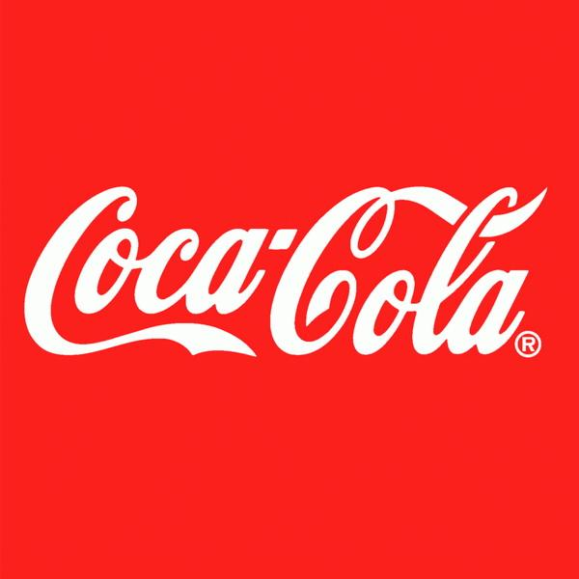 | 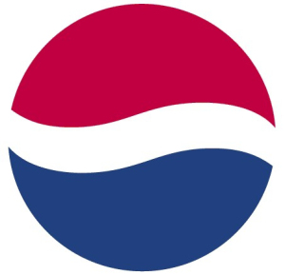
Stylized text | Logo

Goods, Services, & Filing Basis

Actual Use

Are you using this mark for some goods or services that you are currently selling? If so, please
Describe:

- The goods or services that are currently being sold using this mark.
- Your involvement in making / designing / labeling / distributing the goods

Be as specific and complete as possible.

Example: “Rough-and-Tumble is a clothing line for young men. We have been designing and selling hoodies, jeans, T-shirts, sweats, jackets, ball caps, and knit caps and selling them with a Rough-and-Tumble tag. We sell through e-commerce websites and stock some in local shops in Venice Beach. We do not have our own store.”

Your response here:

Intent to Use

Do you intend to use this trademark for some goods or services that you haven’t sold yet, but you will reasonably sell within the next three years? If so, please describe those goods or services here. Be as specific and complete as possible.

Example: “Next year, we intend to expand the Rough-and-Tumble brand to women’s jeans and jackets, and we will sell a high-energy sports drink.”

Your response here:

Distinctiveness

Meaning

If you are submitting a name (word or phrase) please explain what this name means to you (if anything), and why you chose it to represent the goods or services that you provide. If there are any characteristics that make the product unique, it’s great if you can explain or send pictures. This does not apply if you are submitting a strictly graphical mark.

Example: “We call our clothing line ‘Rough and Tumble’ because the clothing is stone-washed to give it an aged, ‘rough and tumble’ look.”

Your response:

Prior Art

Are you aware of any competitors who are using a similar trademark to sell a similar good or service?

Example: “There’s an Instagram profile for ‘Rough and Ready’ jeans. There’s also a ‘Rough and Tumble’ clothing store in Kansas City. They only sell children’s clothes.”

Your answer:

